PACKERLAND CONFERENCE
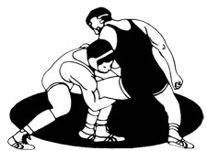
WRESTLING
STANDINGS
DECEMBER 12, 2020

SCHOOL WON LOST TIED
Kewaunee 1 0 0
Southern Door 1 0 0
Oconto 0 1 0
Sturgeon Bay-Sevastopol 0 1 0
Peshtigo 0 0 0

